**Logistics OrderStatus Prediction**

**Project Description:**

The Order Status Prediction project aims to improve the logistics and delivery process by utilising data analysis and machine learning techniques. This project focuses on analysing a dataset that contains various attributes related to orders, such as order dates, shipment modes, product categories, shipping costs, and delivery times, to predict the OrderStatus (e.g., Shipped, Returned, or Cancelled). By performing univariate, bivariate, and multivariate analyses, the project aims to identify patterns and key factors that affect the status of an order. Furthermore, predictive models will be developed to forecast the likelihood of an order being Shipped, Returned, or Cancelled based on historical data. The insights generated from this project will help logistics companies optimise their operations, reduce delivery times, and enhance customer satisfaction, contributing to a more efficient and reliable delivery system.

**Scenario 1: Optimising Order Management for Logistics Companies**

Logistics companies aim to enhance the efficiency of their order management and delivery processes. By implementing insights from the OrderStatus Prediction project, these companies can identify common issues that lead to delayed or incomplete orders, such as shipping delays or incorrect product information. With predictive models, logistics companies can proactively manage orders that are at risk of being delayed or not delivered on time, enabling them to allocate resources more effectively and improve their operations. This leads to faster delivery times, reduces the likelihood of order cancellations, and ensures higher customer satisfaction, ultimately benefiting both the customers and the company's reputation.

**Scenario 2: Enhancing Order Fulfilment for E-commerce Platforms**

An e-commerce platform collaborates with logistics companies to gain insights into the order fulfilment process. By understanding the factors that influence successful and timely deliveries, the platform can better support its logistics partners by providing targeted recommendations, such as optimising shipping routes or choosing the most reliable carriers. Additionally, the platform can use predictive models to forecast which orders are at risk of delays or issues, allowing them to proactively address potential problems. This leads to a more efficient order fulfilment process, reduces delivery times, enhances customer satisfaction, and increases overall service reliability.

**Scenario 3: Enhancing Delivery Performance Monitoring for Logistics Managers**

Logistics managers use insights from the Order Status Prediction project to monitor delivery performance more effectively. By analysing patterns in delayed or incomplete orders, managers can identify systemic issues that may indicate problems with specific shipping methods, carriers, or routes. Predictive models help managers proactively identify orders that may require additional attention or intervention to ensure timely delivery. This enables logistics companies to maintain high delivery standards, improve operational efficiency, and ensure that customers receive their orders promptly, thereby enhancing customer trust and satisfaction.

**Technical Architecture:**

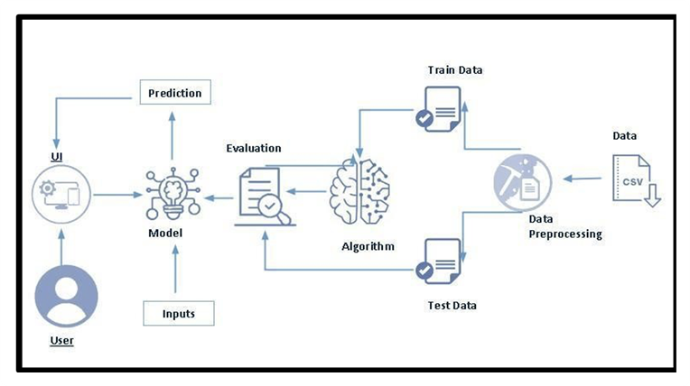

**Project Flow:**

* User interacts with the UI to enter the input.
* Entered input is analysed by the model which is integrated.
* Once model analyses the input the prediction is showcased on the UI

**To accomplish this, we have to complete all the activities listed below:**

* **Data Collection & Preparation**

Collect the dataset

Data Preparation

* **Exploratory Data Analysis**

Descriptive Analysis

Visual Analysis

* **Model Building**

Training the model in multiple algorithms

Testing the model

* **Performance Testing**

Testing model with multiple evaluation metrics

Comparing model accuracy before & after applying hyperparameter tuning

* **Model Deployment**

Save the best model

Integrate with Web Framework

**Prior Knowledge:**

You must have the prior knowledge of the following topics to complete this project.

* ML Concepts:
* Supervised learning: <https://www.javatpoint.com/supervised-machine-learning>
* Decision tree: <https://www.geeksforgeeks.org/python-decision-tree-regression-using-sklearn/>
* Random forest: <https://www.geeksforgeeks.org/random-forest-regression-in-python/>
* Neuralnetwork:https://www.geeksforgeeks.org/classification-of-neural-network-in-tensorflow/
* Flask Basics: [https://www.youtube.com/watch?v=lj4I_CvBnt0](http://www.youtube.com/watch?v=lj4I_CvBnt0)
* AdaBoost:https://www.geeksforgeeks.org/implementing-the-adaboost-algorithm-from-scratch/
* Xgboost: <https://www.geeksforgeeks.org/xgboost/>
* GradientBoost: <https://www.geeksforgeeks.org/ml-gradient-boosting/>
* KNN: <https://www.geeksforgeeks.org/k-nearest-neighbours/>
* logistic Regression: https://www.geeksforgeeks.org/understanding-logistic-regression/

**Project Structure:**

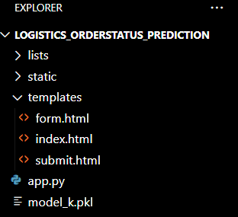

Here lists is the virtual environment

**Milestone 1: Data Collection & Preparation**

ML depends heavily on data. It is the most crucial aspect that makes algorithm training possible. So, this section allows you to download the required dataset.

**Activity 1: Collect the Dataset**

There are many popular open sources for collecting data, such as Kaggle.com and the UCI Machine Learning Repository. In this project, we have used a synthetic .csv dataset specifically created for analysing logistics and order management processes.

This dataset contains detailed information about orders, including order ID, order and shipment dates, product categories, shipping modes, delivery times, and order statuses. By analysing this synthetic data, we can derive insights into factors that affect delivery times, identify common causes of delays, and predict the likelihood of on-time delivery based on historical trends.

The dataset, "logistics_synthetic_data_realistic_v1.csv," contains numerous observations, providing a realistic simulation of real-world logistics scenarios. By applying various visualisation and analysis techniques, we can effectively interpret the data and gain valuable insights to optimise logistics operations and improve overall efficiency.

Dataset: [Link](https://drive.google.com/file/d/1tcgr_eN0_eUeI3WjuZzo6Izwri8GSA5I/view?usp=drive_link)

As the dataset is downloaded. Let us read and understand the data properly with the help of some visualisation techniques and some analysing techniques.

**Note:** There are a number of techniques for understanding the data. But here we have used some of it. In an additional way, you can use multiple techniques.

**Activity 1.1: Importing the libraries**

Import the necessary libraries as shown in the image.

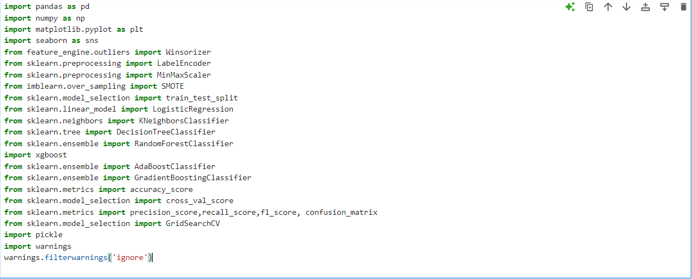

## **Activity 1.2: Read the Dataset**

Our dataset format might be in .csv, excel files, .txt, .json, etc. We can read the dataset with the help of pandas. In pandas we have a function called read_csv() to read the dataset. As a parameter we have to give the directory of the csv file.

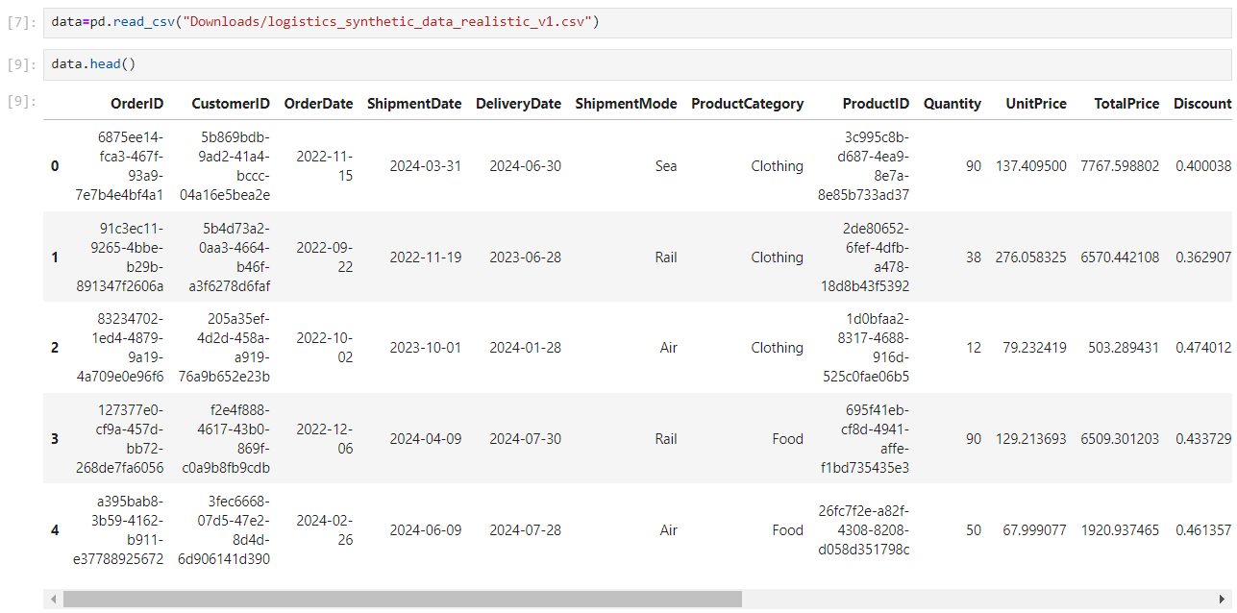

## **Activity 1.3: Data Preprocessing**

## 

## 

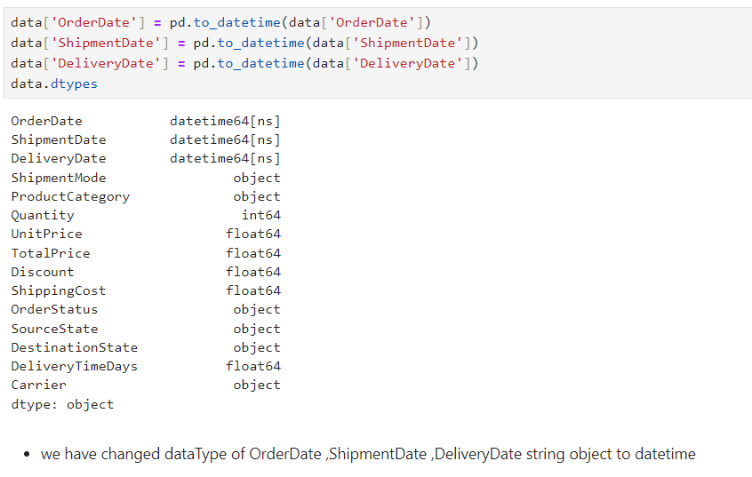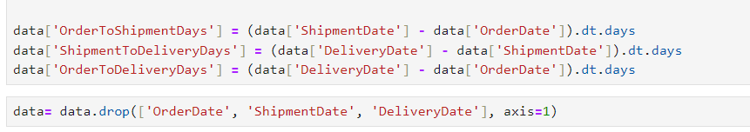

**Activity 2: Data Preparation**

As we have understood how the data is, let's pre-process the collected data.

The download data set is not suitable for training the machine learning model as it might have so much randomness so we need to clean the dataset properly in order to fetch good results.

This activity includes the following steps.

* Handling Duplicate values
* Handling missing values
* Handling Outliers
* Handling categorical data

Note: These are the general steps of pre-processing the data before using it for machine learning. Depending on the condition of your dataset, you may or may not have to go through all these steps.

**Activity 2.1: Handling Duplicate Values**

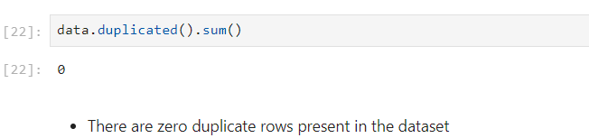

**Activity 2.2: Handling Missing Values**

For checking the null values, df.isnull() function is used. To sum those null values, we use .sum() function. From the below image we found that there no null values present in our dataset:

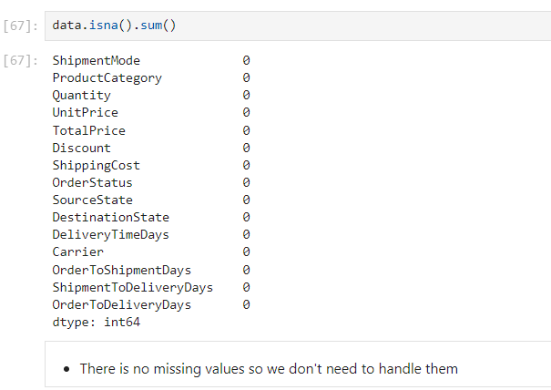

**Activity 2.3: Handling Outliers**

To handle outliers in the dataset, the process involves identifying and treating anomalous data points that deviate significantly from the majority of the data. These outliers can skew the analysis and negatively impact the performance of machine learning algorithms, making it essential to address them before proceeding with further analysis and prediction tasks.

Addressing outliers is crucial for ensuring the accuracy and reliability of the subsequent stages of analysis and prediction in the project.

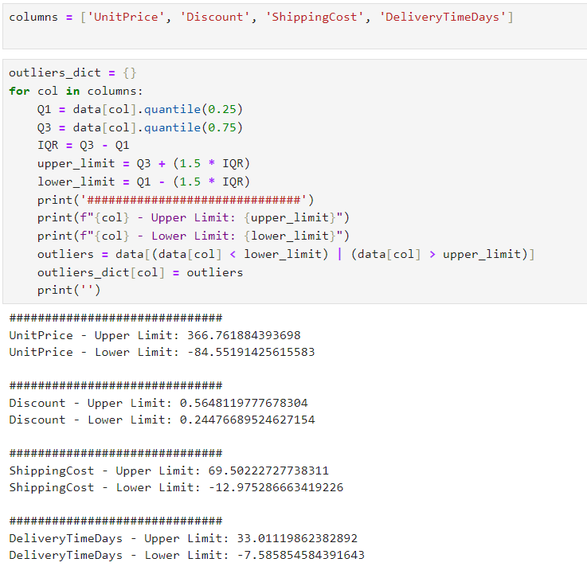

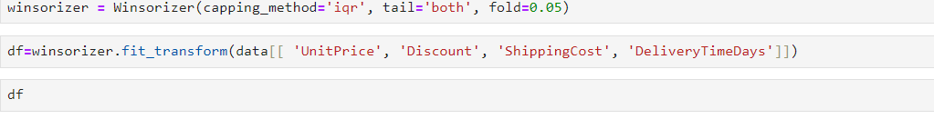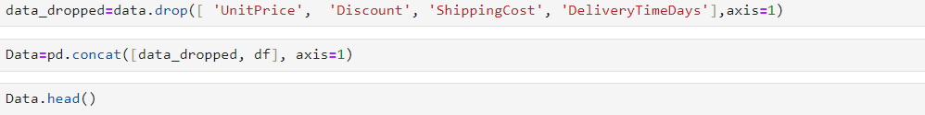

**Activity 2.4: Changing the datatype of class from object to int**

The categorical columns in the dataset are being encoded into numerical values using Label Encoding. This process is essential for converting non-numeric data, such as application status and requirement completions, into a format that can be used by machine learning algorithms.This is crucial for the subsequent stages of analysis and prediction in the project.

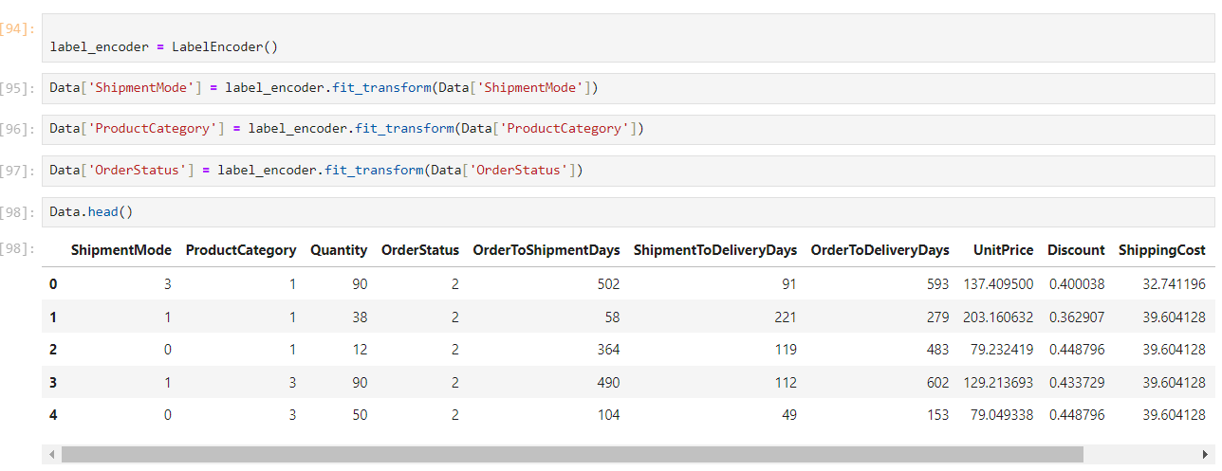

**Activity 2.5: Scaling Data**

Scaling is a crucial preprocessing step in data analysis that involves transforming numerical features to a consistent scale, ensuring that no single feature disproportionately influences the results. In the context of the Logistics Order Status Prediction project, scaling helps standardize features such as delivery time, order quantity, and shipping distance, so that they are all on the same scale.

This is particularly important when using machine learning algorithms, as features with larger ranges can dominate the learning process, leading to biased models. Techniques such as Min-Max Scaling (which scales features to a range of 0 to 1) or Standardization (which centers features around the mean with a standard deviation of 1) are commonly applied. Proper scaling enhances the accuracy and performance of the predictive models, leading to more reliable order status predictions and better decision-making in logistics operations.

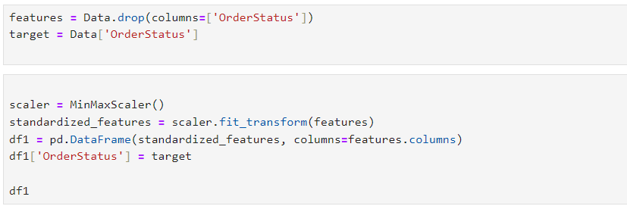

**Milestone 2: Exploratory Data Analysis**

**Activity 1: Descriptive Analysis**

Descriptive analysis involves examining fundamental characteristics of data using statistical methods. Pandas offers a valuable function known as 'describe' for this purpose. Utilizing the 'describe' function enables us to uncover unique, top, and frequently occurring values within categorical features. Moreover, it provides insights into the mean, standard deviation, minimum, maximum, and percentile values of continuous features.

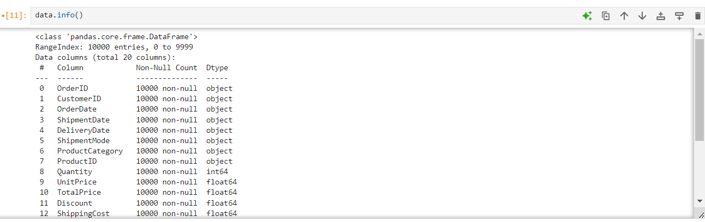

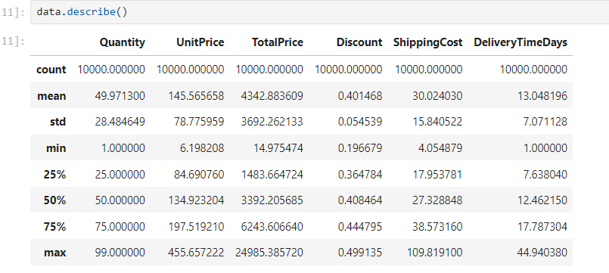

**Activity 2: Visual analysis**

Visual analysis is the process of using visual representations, such as charts, plots, and graphs, to explore and understand data. It is a way to quickly identify patterns, trends, and outliers in the data, which can help to gain insights and make informed decisions.

**Activity 2.1: Univariate analysis**

In simple words, univariate analysis is understanding the data with a single feature. Here we have displayed a plot that is a count plot.

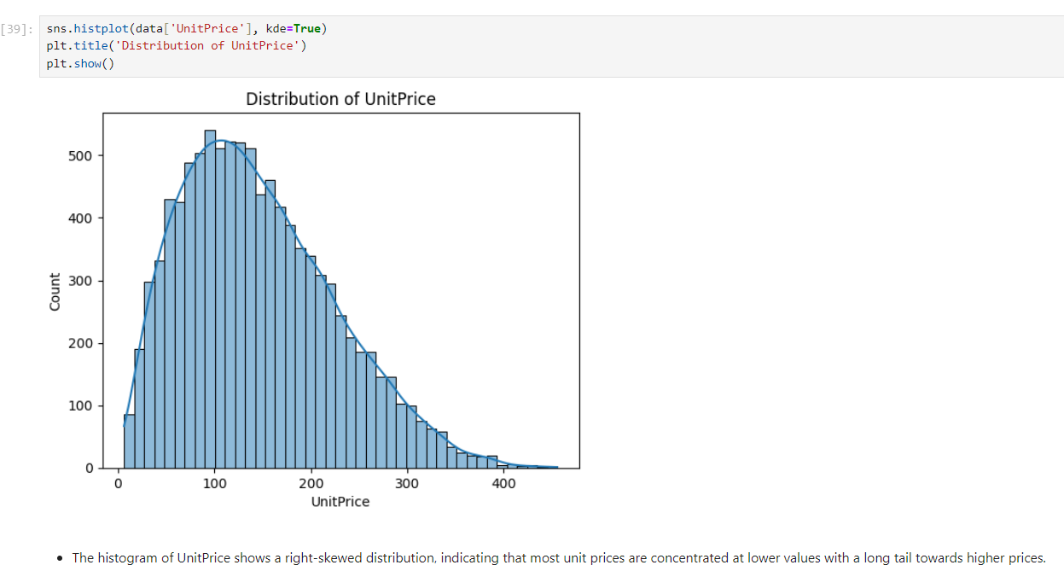

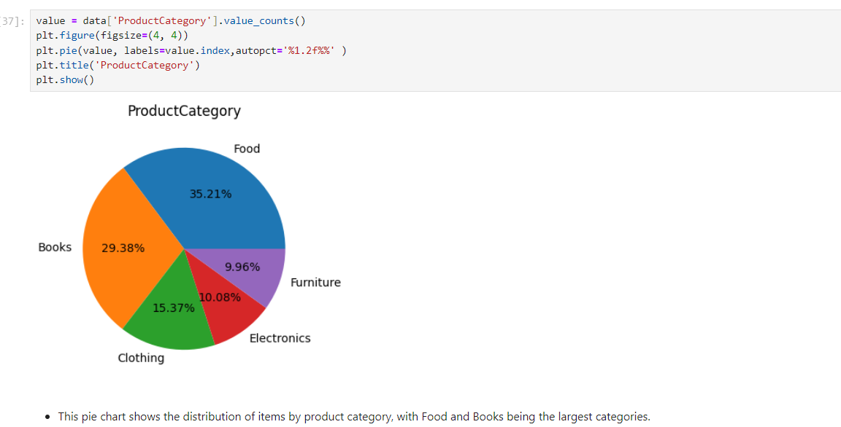

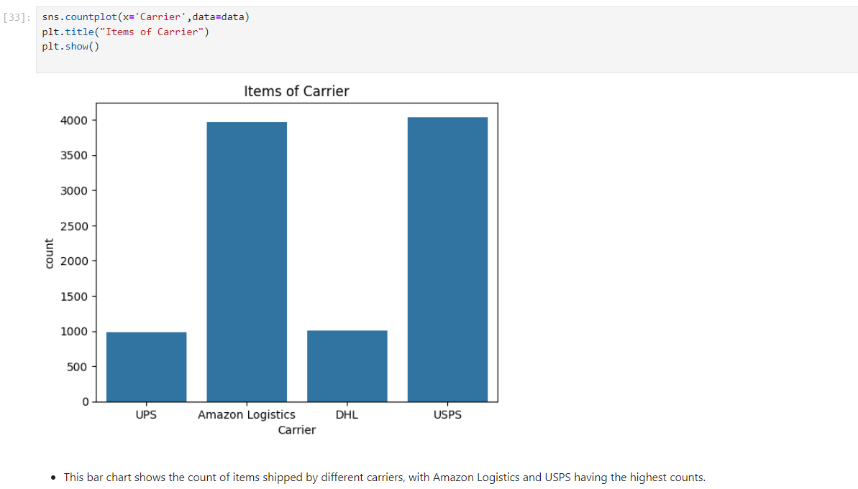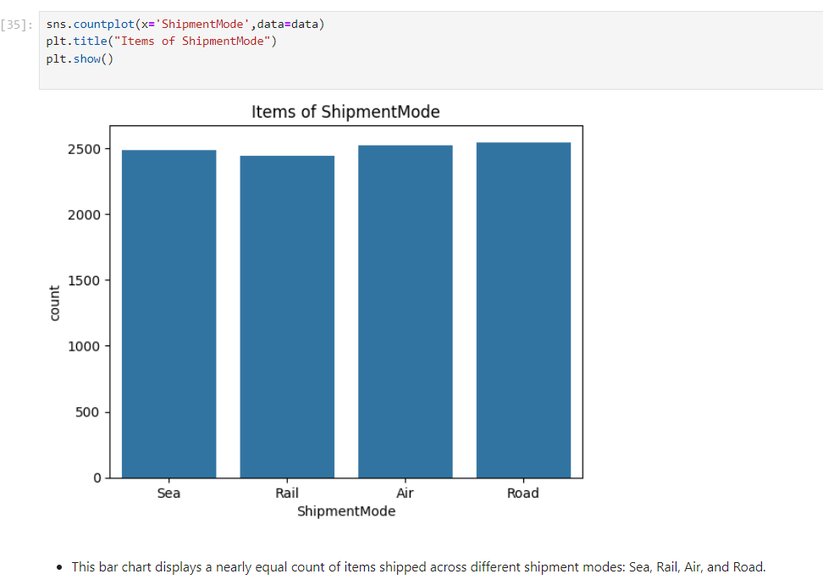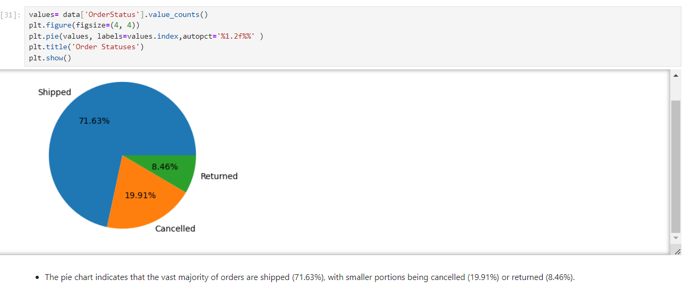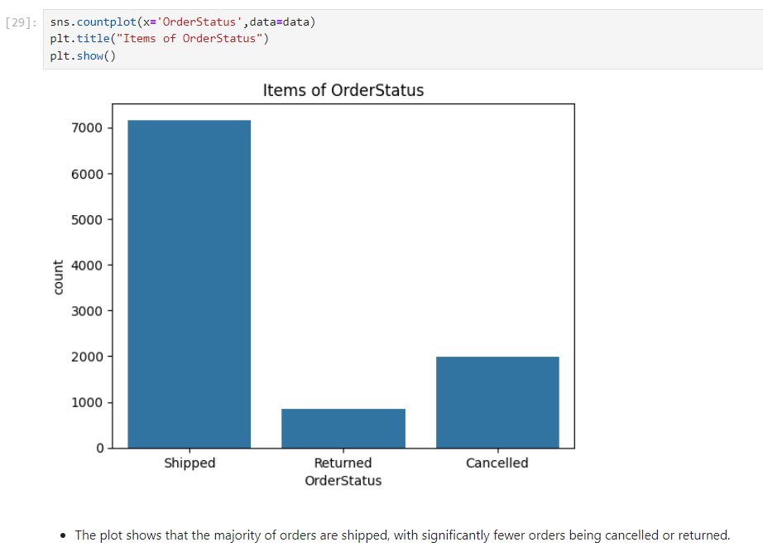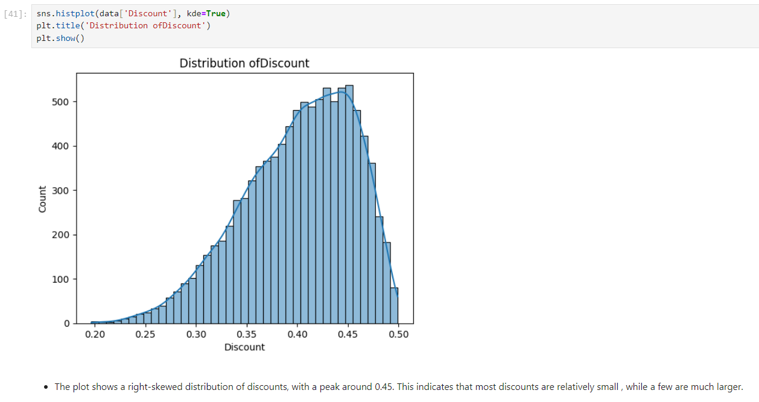

**Activity 2.2: Bivariate analysis**

Bivariate analysis is employed to explore the relationship between two features

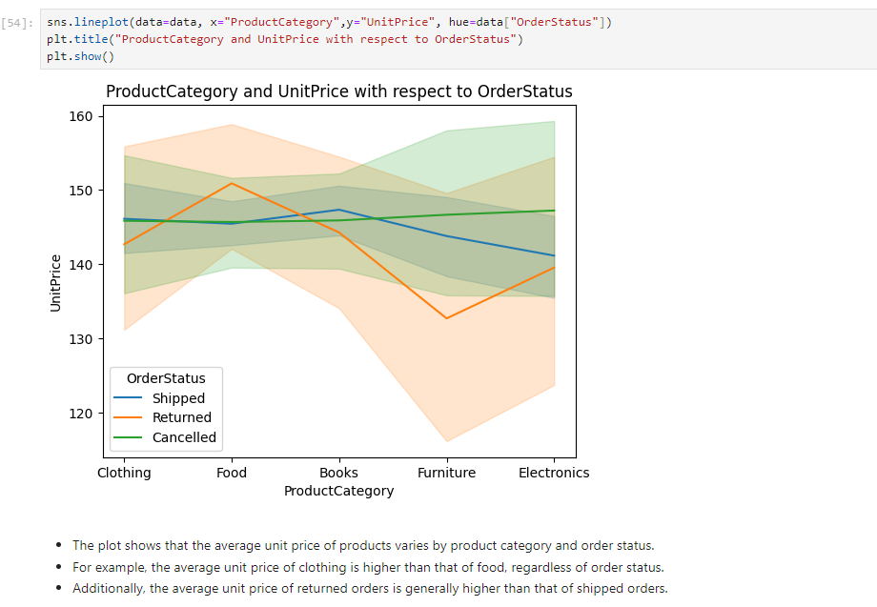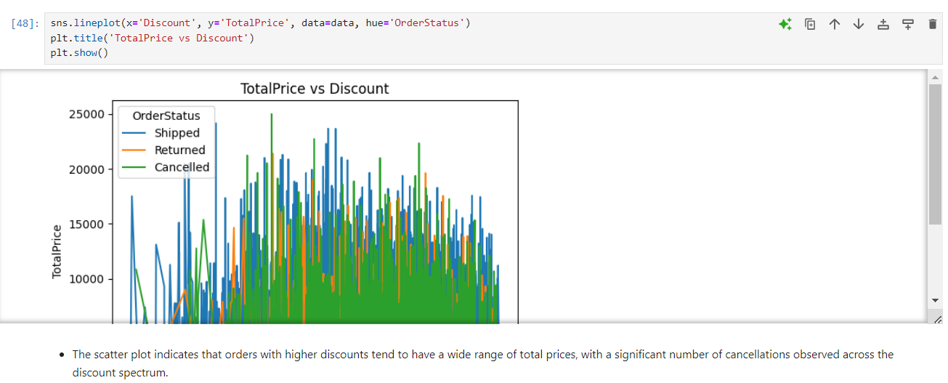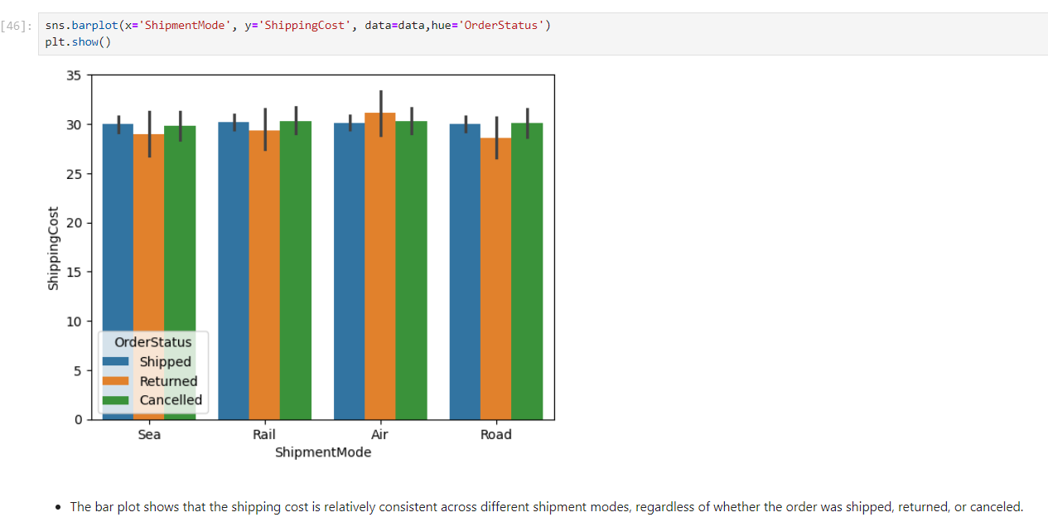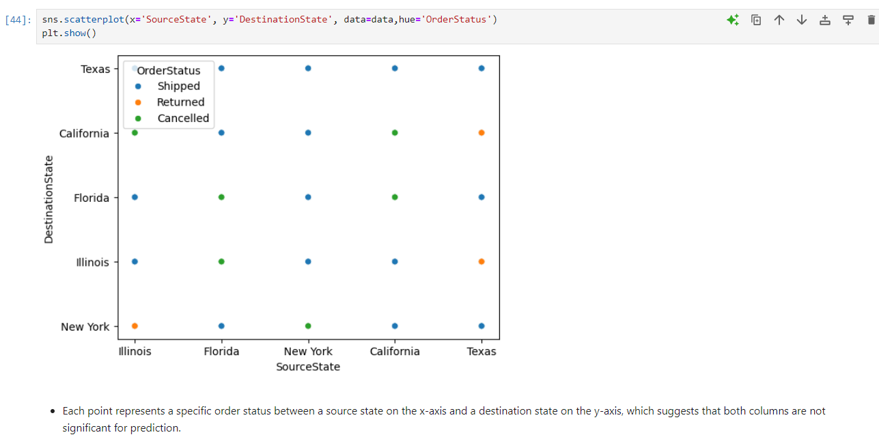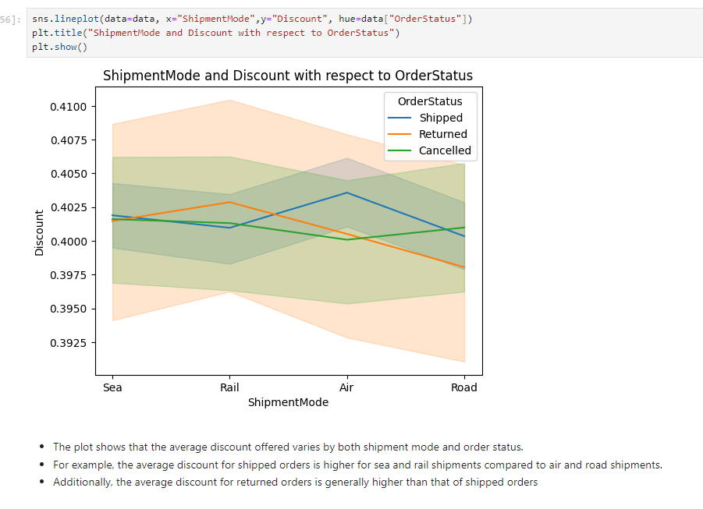

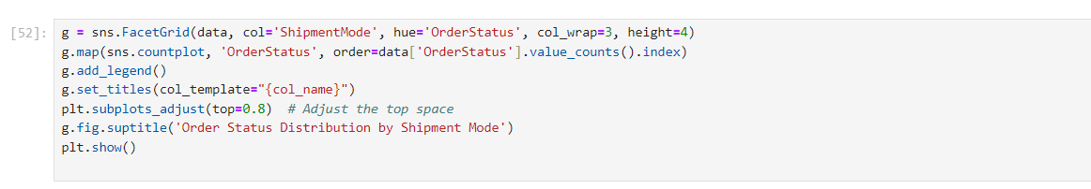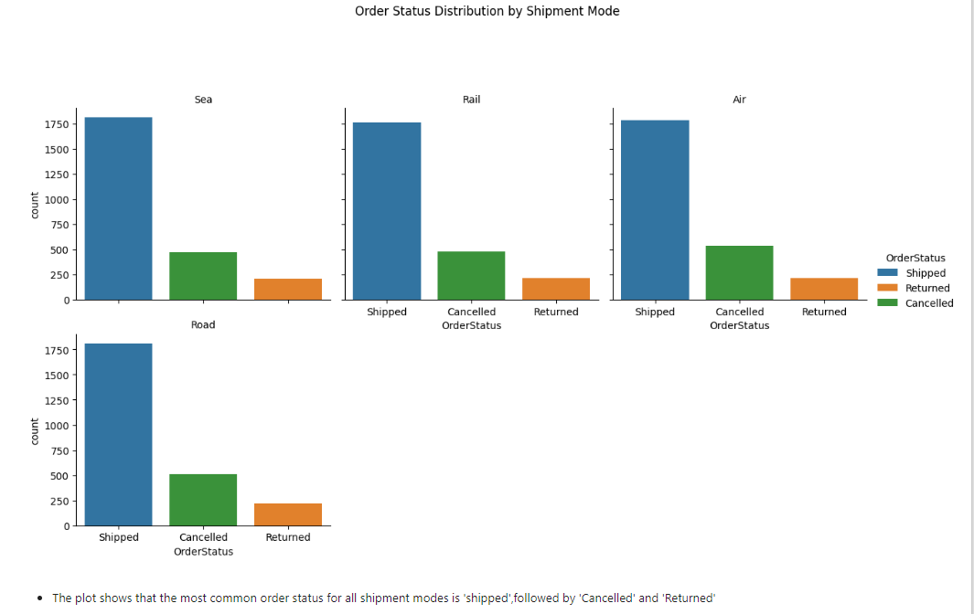

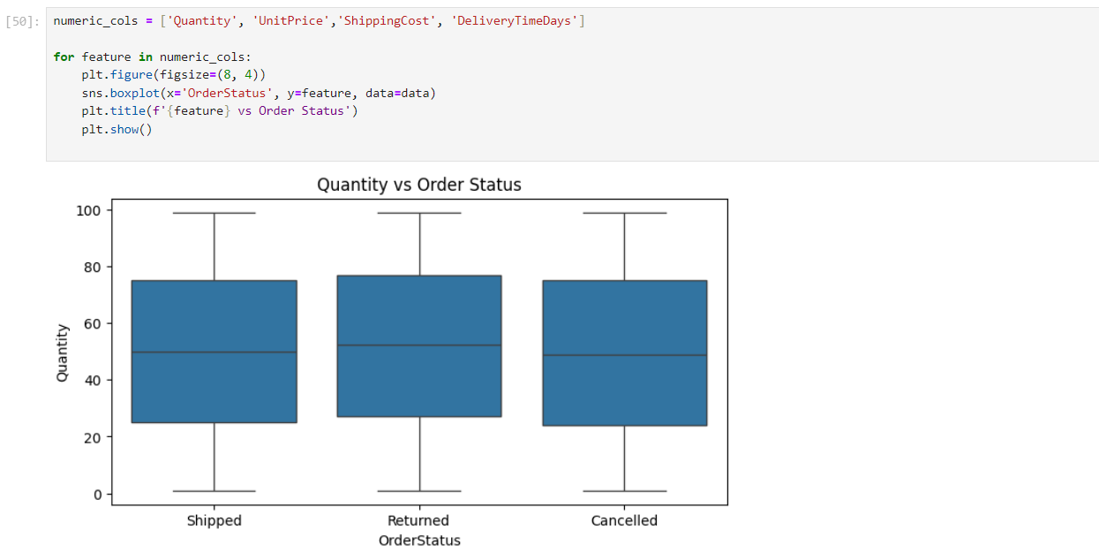

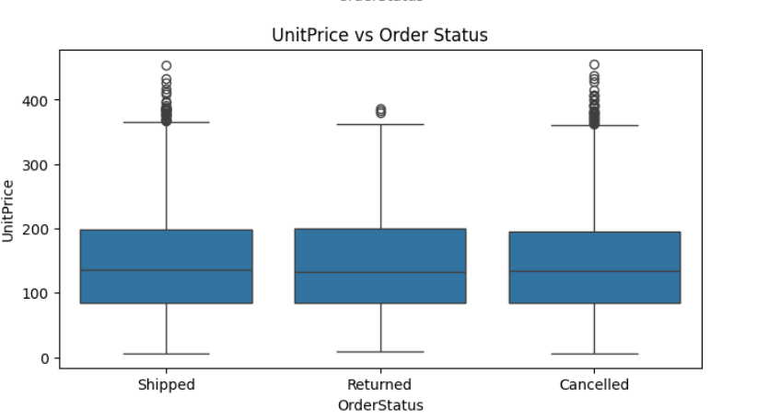

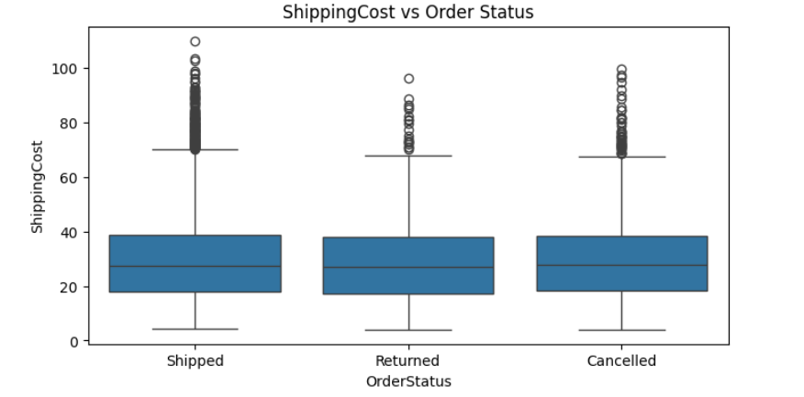

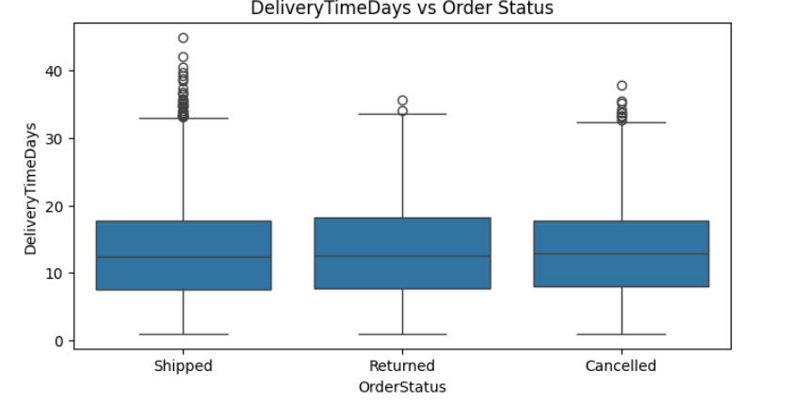

**Activity 2.3: Multivariate Analysis**

Multivariate Analysis is a statistical technique used to understand relationships between three or more variables simultaneously. In the context of the Logistics Order Status Prediction project, multivariate analysis helps uncover complex interactions and patterns across multiple order-related features, such as how the combination of delivery time, shipping method, and order quantity might influence the final order status. This analysis is crucial for identifying key factors that impact whether an order is Shipped on time, delayed, or cancelled, enabling more accurate predictions and improving overall logistics efficiency.

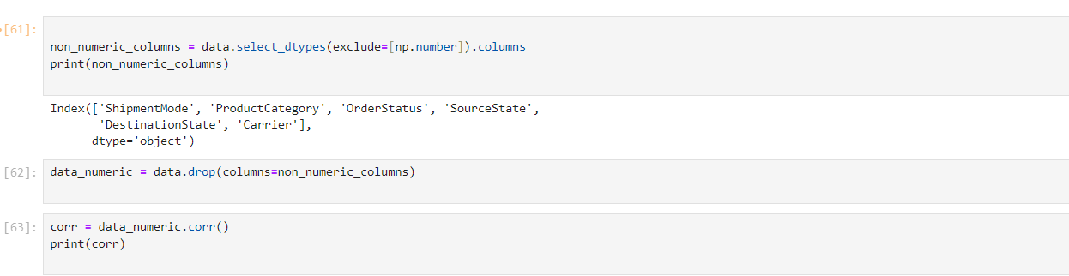

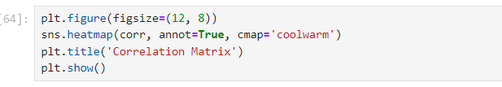

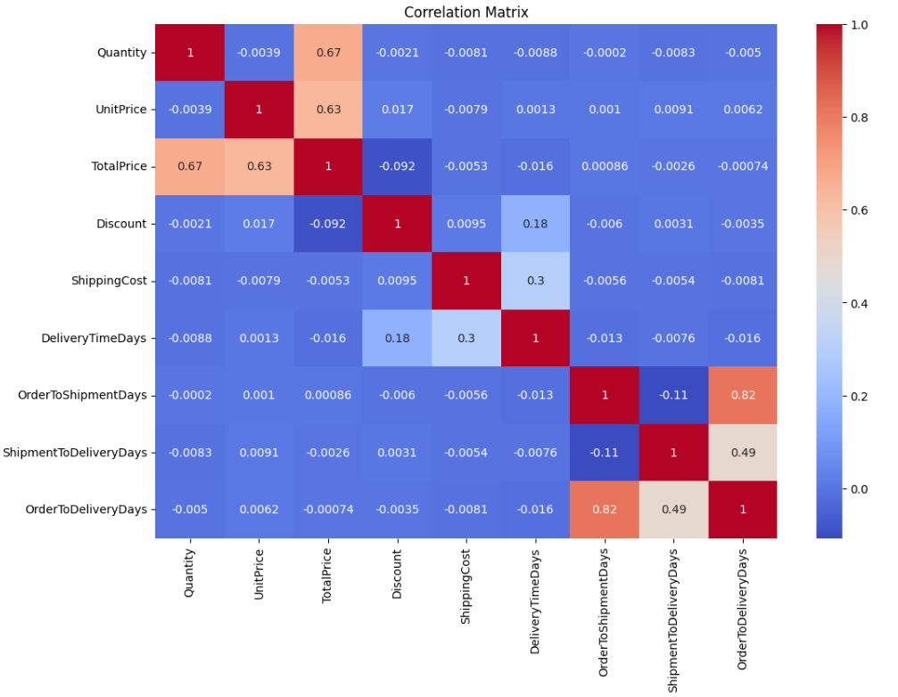

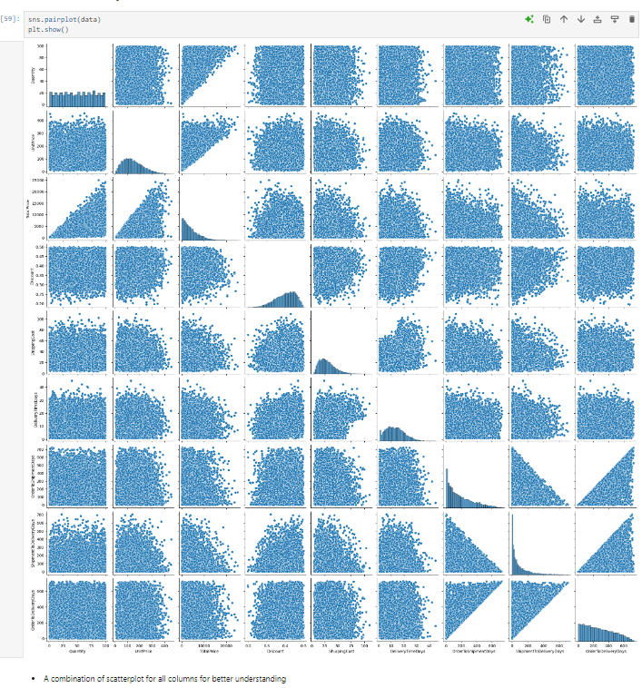

**Activity 3: Splitting data into train and test**

This step involves preparing the dataset for machine learning by separating it into features (X) and the target variable (y), and then dividing the data into training and testing sets. The features (X) are obtained by removing the Status column from the dataset, while y is the Status column itself, representing the application outcomes that the model aims to predict. The dataset is then split into 80% for training and 20% for testing using the train_test_split function, with a random_state set to 42 for reproducibility. This approach ensures that the model is trained on one portion of the data and evaluated on a different portion, providing a reliable assessment of its performance.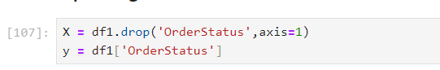

**Activity 3.1: Handling Imblanced**

Handling imbalanced data is a crucial step when dealing with classification problems where one class significantly outnumbers the others. In the context of the Logistics Order Status Prediction project, imbalanced handling ensures that the model does not become biased towards the majority class, which could lead to poor performance in predicting the minority class, such as Returned or canceled orders. By applying these techniques, the Logistics Order Status Prediction model can be better equipped to handle imbalanced data, resulting in more accurate predictions across all order statuses, including those that are less frequent but critical, such as delays or cancellations.

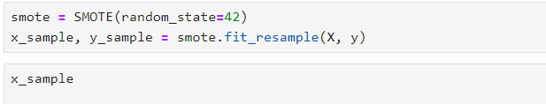

Splitting the data into train and test data



**Milestone 3: Model Building**

**Activity 1: Training and testing the models using multiple algorithms**

Now our data is cleaned and it’s time to build the model. We can train our data on different algorithms. For this project we are applying three classification algorithms. The best model is saved based on its performance. Seven machine learning models—Logistic Regression, KNN, Random Forest Classifier , Decision Tree Classifier, Xgboost, AdaBoost, GradientBoost Classifer are initialized for predicting the application status.

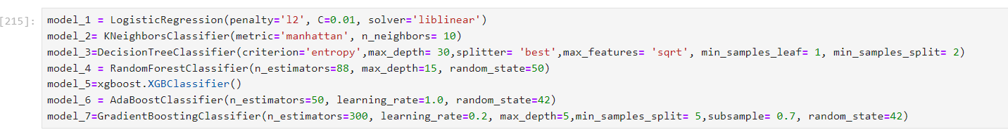

**Activity 2.1: Logistic Regression:**

The code trains a Logistic Regression model on the training data and evaluates its performance on the test data. After training the model using the fit method, predictions are made on the test set, and the accuracy of these predictions is calculated and displayed. Additionally, a confusion matrix is generated to provide a detailed breakdown of the model's performance, showing the number of correct and incorrect predictions across different classes. This helps in understanding how well the model is distinguishing between different application statuses.

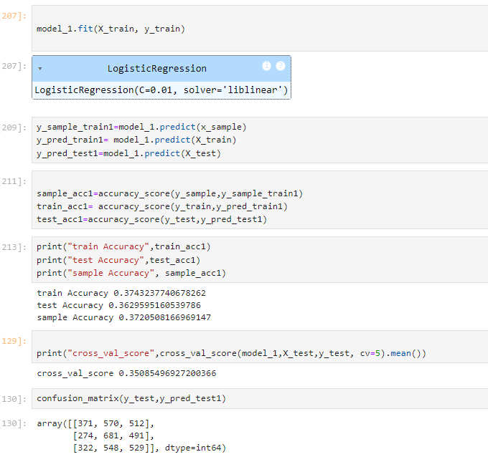

**Activity 2.2: K-Nearest Neighbors (KNN) :**

The code trains a K-Nearest Neighbors (KNN) model on the training data, incorporates hyperparameter tuning to optimize the model, and evaluates its performance on the test data. After fitting the model using the fit method with the best hyperparameters, predictions are made on the test set, and the accuracy of these predictions is calculated and displayed.

Hyperparameter tuning is performed using techniques such as Grid Search or Random Search, where different values for parameters like the number of neighbors (n_neighbors), distance metrics (metric), and weights (weights) are explored to find the optimal configuration that maximizes model performance.

Additionally, a confusion matrix is generated to assess the model's performance across various metrics, including true positives, true negatives, false positives, and false negatives. This matrix provides insights into how well the tuned KNN model differentiates between different application statuses, helping to identify any potential areas of improvement and ensuring that the model generalizes well to unseen data.

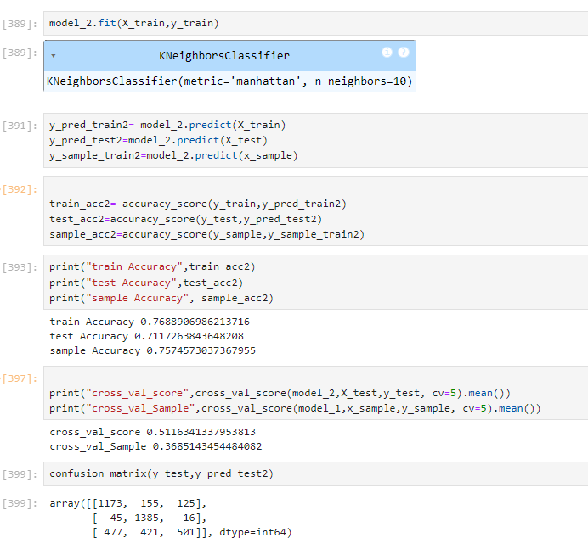

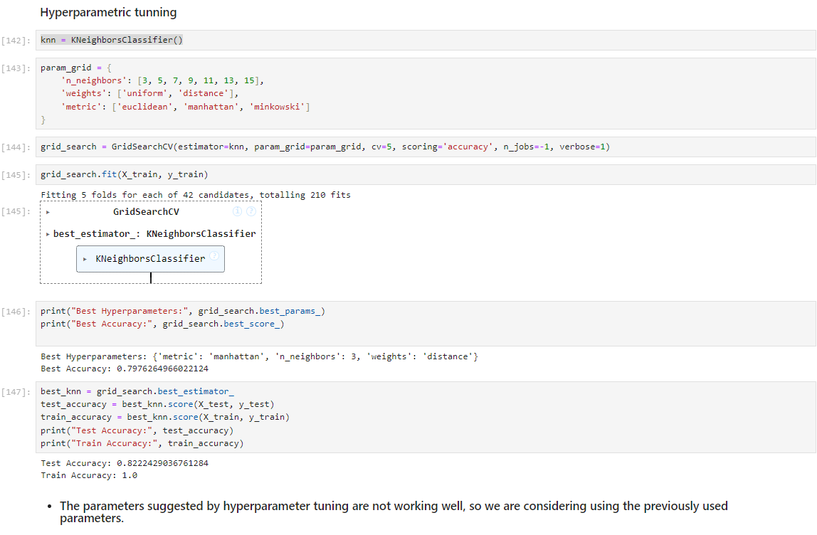

**Activity 2.3 : Random Forest Classifier**

The code trains a Random Forest Classifier model on the training data and evaluates its performance on the test data. After fitting the model using the fit method, predictions are made on the test set, and the accuracy of these predictions is calculated and displayed. A confusion matrix is also generated to provide a detailed view of the model's performance, showing the number of true positives, true negatives, false positives, and false negatives, which helps in assessing how well the Random Forest model classifies the application statuses.

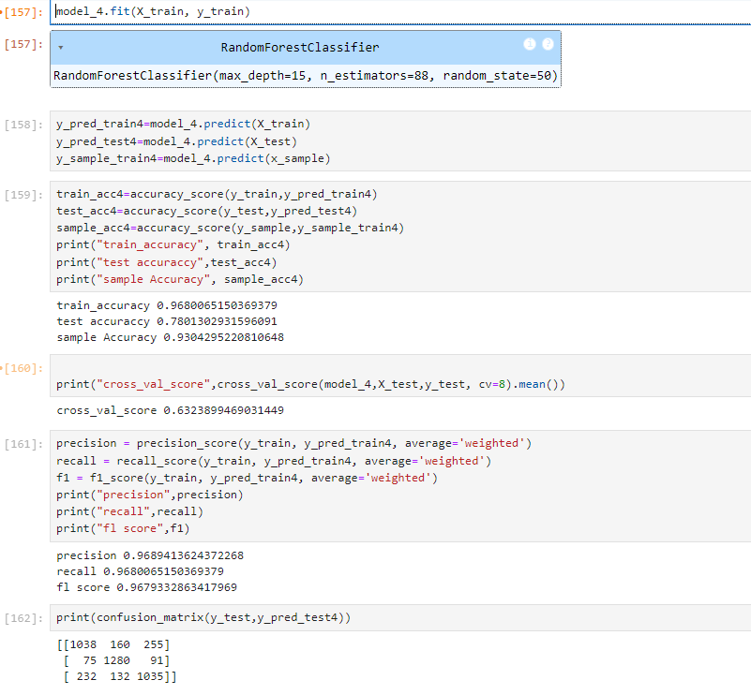

**Activity 2.4 : Decision Tree Classifier**

The code trains a Decision Tree Classifier model on the training data and evaluates its performance on the test data. After fitting the model with the fit method, predictions are made on the test set, and the accuracy of these predictions is calculated and printed. Additionally, a confusion matrix is generated to provide a detailed breakdown of the model's performance, showing true positives, true negatives, false positives, and false negatives, which helps in understanding how effectively the Decision Tree model classifies the application statuses.

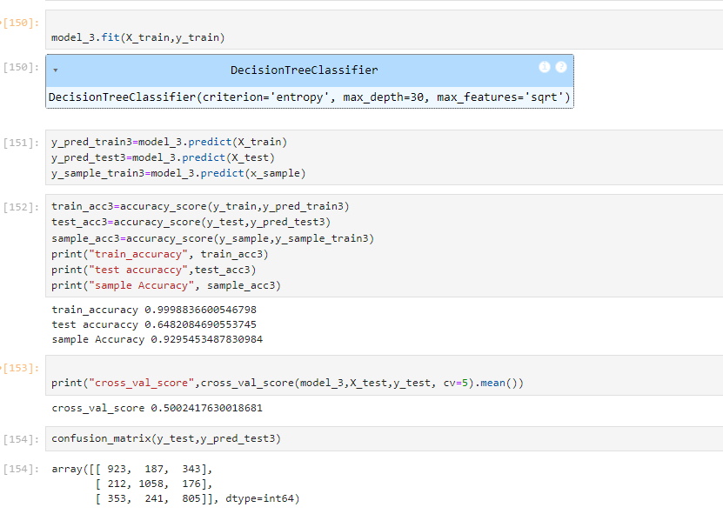

**Activity 2.5: Xgboost**

The code trains an XGBoost model on the training data, incorporates hyperparameter tuning to optimize the model, and evaluates its performance on the test data. After fitting the model using the fit method with the best hyperparameters, predictions are made on the test set, and the accuracy of these predictions is calculated and displayed. This approach ensures that the XGBoost model is not only trained effectively but also optimized to deliver the best possible performance, with a detailed evaluation of its ability to classify different application statuses accurately.

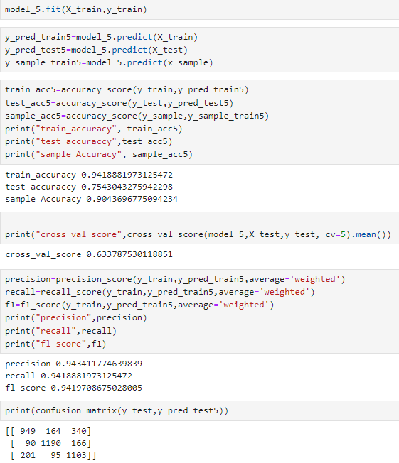

**Activity 2.6 : AdaBoost**

The code trains an AdaBoost model on the training data, incorporates hyperparameter tuning to optimize the model, and evaluates its performance on the test data. After fitting the model using the fit method with the best hyperparameters, predictions are made on the test set, and the accuracy of these predictions is calculated and displayed. This process ensures that the AdaBoost model is not only trained with a focus on accuracy but also fine-tuned to deliver the best possible performance in distinguishing between various application statuses. The detailed evaluation via the confusion matrix helps in understanding the strengths and weaknesses of the model, enabling further refinement if necessary.

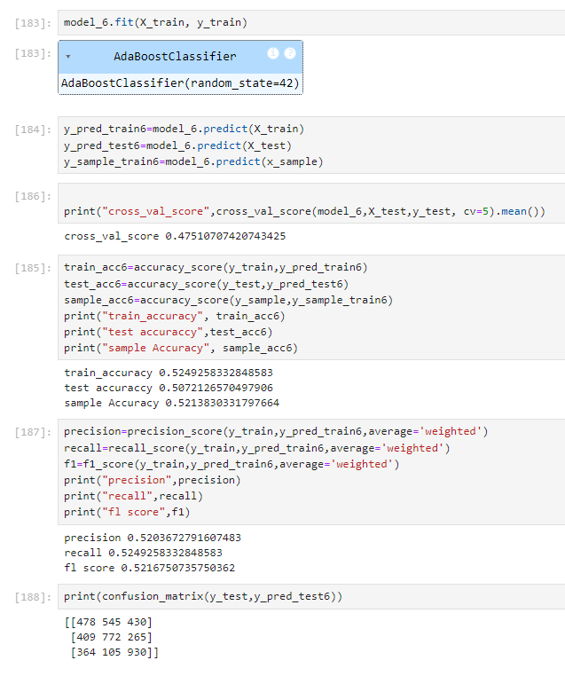

**Activity 2.7 : Gradient Boost Classifier:**

The code trains a Gradient Boosting model on the training data, incorporates hyperparameter tuning to optimize the model, and evaluates its performance on the test data. After fitting the model using the fit method with the best hyperparameters, predictions are made on the test set, and the accuracy of these predictions is calculated and displayed. This process ensures that the Gradient Boosting model is effectively trained and optimized to provide the best possible performance in predicting various application statuses. The confusion matrix allows for a detailed evaluation of the model's classification abilities, identifying areas where the model performs well and areas that might require further improvement.

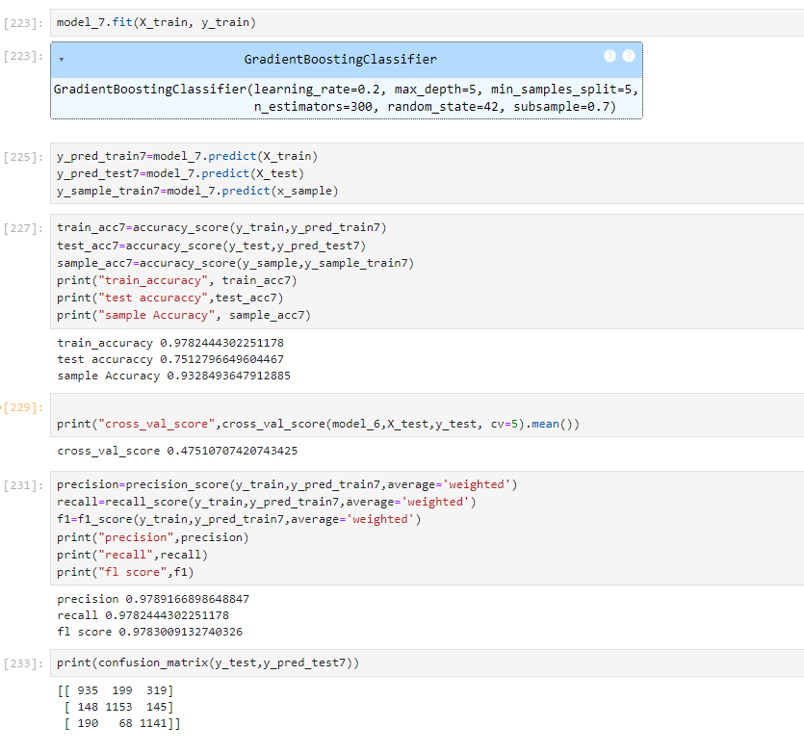

**Activity 3: Selecting the most model by accuracies**

The process involves comparing the train and test accuracies of seven different models—Logistic Regression, KNN, Random Forest, Decision Tree, XGBoost, AdaBoost, and Gradient Boost—to determine the best-performing model. Instead of simply selecting the model with the highest test accuracy, the focus is on identifying the model that demonstrates minimal overfitting, indicated by a small difference between train and test accuracy. In this context, KNN (model_2) is selected as the best model due to its inherent features that naturally balance performance and reduce overfitting. The name of the best model, model_2, and its corresponding accuracy metrics are then printed, highlighting KNN as the model that provided the most balanced performance in predicting the application statuses.

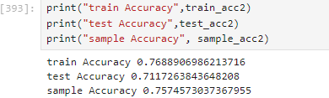

## **Activity 4: Test the model:**

Let’s test the model first in the python notebook itself. As we have 10 features in this model, let’s check the output by giving all the inputs.

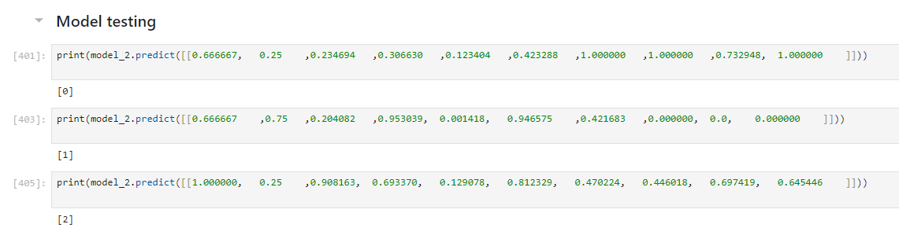

The predicted value and actual value are almost the same.

**Milestone 4: Model Deployment**

# **Activity 1: Save and load the best model**

Saving the best model after comparing its performance using different evaluation metrics means selecting the model with the highest performance. This can be useful in avoiding the need to retrain the model every time it is needed and also to be able to use it in the future.

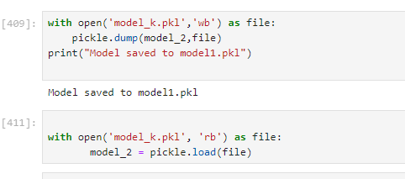

## 

**Activity 2: Integrate with Web Framework**

In this section, we will be building a web application that is integrated to the model we built. A UI is provided for the uses where he has to enter the values for predictions. The enter values are given to the saved model and prediction is showcased on the UI.

This section has the following tasks

* Building HTML Pages
* Building server-side script
* Run the web application

**Activity 3.1: Building Html Pages:**

For this project create 5 HTML files namely

* index.html
* form.html
* about.html
* contact.html
* submit.html

and save them in the templates folder.

**Activity 3.2: Build Python code:**

Import the libraries

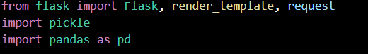

Load the saved model. Importing the flask module in the project is mandatory. An object of Flask class is our WSGI application. Flask constructor takes the name of the current module (__name__) as argument.

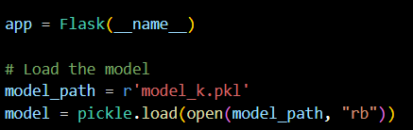

Render HTML page:

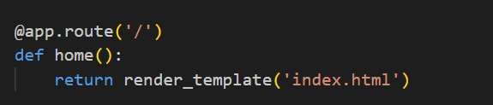

Here we will be using a declared constructor to route to the HTML page which we have created earlier.

In the above example, ‘/’ URL is bound with the home.html function. Hence, when the home page of the web server is opened in the browser, the html page will be rendered.

Whenever you enter the values from the html page the values can be retrieved using POST and GET Methods.

Retrieving the value from UI:

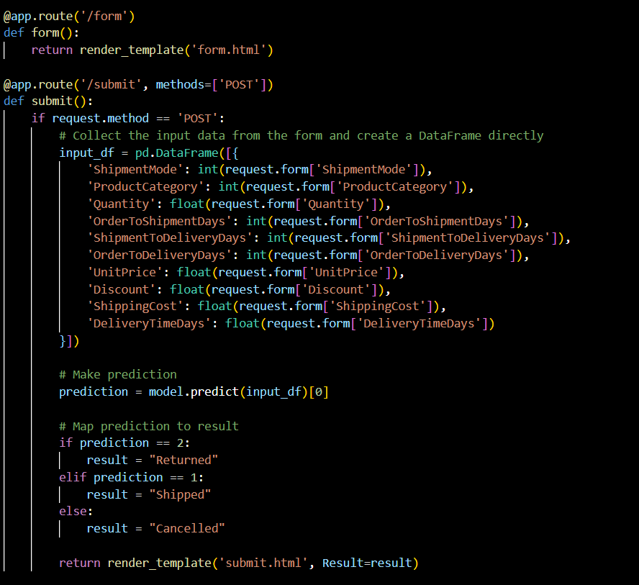

Here we are routing our app to conditional statements. This will retrieve all the values from the HTML page using Post request. That is stored in an array. This array is passed to the model.predict() function. This function returns the prediction. And this prediction value will be rendered to the text that we have mentioned in the submit.html page earlier.

Main Function:

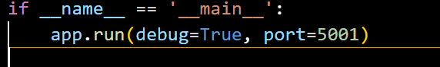

**Activity 3.3: Run the web application**

* Open vs code from the start menu
* Navigate to the folder where your python script is.
* Now type “python app.py” command
* Navigate to the localhost where you can view your web page.
* Click on the predict button, enter the inputs, click on the submit button, and see the result/prediction on the web.

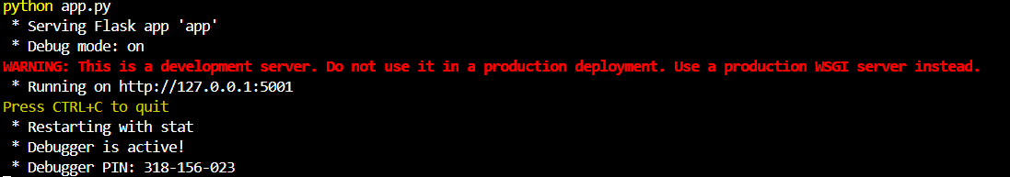

Now, Go to the web browser and write the localhost url (http://127.0.0.1:5001) to get the below results

